##### TRAKREX

**A PROJECT REPORT**

###### ***Submitted by***

##### MOHAJIT PAUL (20BCE10630)

##### YASH MANIKONDA (20BCE10535)

##### AASHAY KULKARNI (20BCE10402)

##### MADHAV GUPTA (20BCE10020)

##### PARITOSH NIMDEO (20BCE10490)

*in partial fulfillment for the award of the degree*

*of*

##### BACHELOR OF TECHNOLOGY

*in*

**COMPUTER SCIENCE AND ENGINEERING**



**SCHOOL OF COMPUTING SCIENCE AND ENGINEERING**

**VIT BHOPAL UNIVERSITY**

**KOTHRIKALAN, SEHORE**

**MADHYA PRADESH - 466114**

DEC 2021

**VIT BHOPAL UNIVERSITY, KOTHRIKALAN, SEHORE**

**MADHYA PRADESH – 466114**

**BONAFIDE CERTIFICATE**

Certified that this project report titled **“TRAKREX”** is the bonafide work of “**MOHAJIT PAUL (20BCE10630), YASH MANIKONDA (20BCE10535), AASHAY KULKARNI (20BCE10402), MADHAV GUPTA (20BCE10020), PARITOSH NIMDEO (20BCE10490)”** who carried out the project work under my supervision. Certified further that to the best of my knowledge the work reported at this time does not form part of any other project/research work based on which a degree or award was conferred on an earlier occasion on this or any other candidate.

**PROGRAM CHAIR PROJECT GUIDE**

Dr. Sandip Mal, Assistant Senior Prof. Dr. Sandip Mal, Assistant Senior Prof.

School of Computer Science and Engineering School of Computer Science and Engineering

VIT BHOPAL UNIVERSITY VIT BHOPAL UNIVERSITY

The Project Exhibition I Examination is held on _______________

**ACKNOWLEDGEMENT**

First and foremost we would like to thank the Lord Almighty for His presence and immense blessings throughout the project work.

We wish to express our heartfelt gratitude to Dr. Sandip Mal, Head of the Department, School of Computer Science and Engineering, for much of his valuable support and encouragement in carrying out this work.

We would like to thank my internal guide Dr. Sandip Mal , for continually guiding and actively participating in our project, giving valuable suggestions to complete the project work.

We would like to thank all the technical and teaching staff of the School of Computer Science and Engineering, who extended directly or indirectly all support.

Last, but not least, we are deeply indebted to our parents who have been the greatest support while we worked day and night for the project to make it a success.

**TABLE OF CONTENTS**

|  |  |  |
| --- | --- | --- |
| **CHAPTER NO.** | **TITLE** | **PAGE NO.** |
|  | List of Abbreviations  List of Figures and Graphs  List of Tables  Abstract | -  7  7  7 |
| 1 | **CHAPTER-1:**  **PROJECT DESCRIPTION AND OUTLINE** Introduction 1.2 Motivation for the work  1.3 [About Introduction to the project  including techniques]  1.4 Problem Statement  1.5 Organization of the project  1.6 Summary | 9  .  .  .  .  .  . |
| 2 | **CHAPTER-2:**  **RELATED WORK INVESTIGATION**  2.1 Introduction  2.2 <Core area of the project>  2.3 Existing Approaches/Methods  2.3.1 Approaches/Methods -1  2.4 <Pros and cons of the stated Approaches/Methods >  2.5 Issues/observations from investigation  2.6 Summary | 10  .  .  .  .  .  .  .  . |
| 3 | **CHAPTER-3:**  **REQUIREMENT ARTIFACTS**  3.1 Introduction  3.2 Hardware and Software requirements  3.3 Specific Project requirements  3.3.1 Data requirement  3.3.2 Functions requirement  3.4 Summary | 11  .  .  .  .  .  . |
| 4 | **CHAPTER-4:**  **DESIGN METHODOLOGY AND ITS NOVELTY**  4.1 Methodology and goal  4.2 Functional modules design and analysis  4.3 Software Architectural designs  4.4 User Interface designs | 12  .  .  .  . |
| 5 | **CHAPTER-5:**  **TECHNICAL IMPLEMENTATION & ANALYSIS**  5.1Outline  5.2 Technical coding and code solutions  5.3 Working Layout of Forms  5.4 Prototype submission  5.5 Test and validation  5.6 Performance Analysis(Graphs/Charts) | 14  .  .  .  .  .  . |
| 6 | **CHAPTER-6:**  **PROJECT OUTCOME AND APPLICABILITY**  6.1Outline  6.2 Key implementations outlines of the system  6.3 Significant project outcomes  6.4 Project applicability on Real-world applications  6.5 Inference | 22  .  .  .  .  . |
| 7 | **CHAPTER-7:**  **CONCLUSIONS AND RECOMMENDATION**  7.1Outline  7.2 Limitation/Constraints of the System  7.3 Future Enhancements  7.4 Inference | 24  .  .  .  . |
|  | Appendix A  Appendix B  References | -  -  25 |

**LIST OF FIGURES AND GRAPHS**

|  |  |  |
| --- | --- | --- |
| **FIGURE NO.** | **TITLE** | **PAGE NO.** |
| 1 | Design and Analysis of Functional Modules | 12 |
| 2 | Software Architectural Design | 13 |
| 3 | Working Layout | 17 |

**LIST OF TABLES**

|  |  |  |
| --- | --- | --- |
| **FIGURE NO.** | **TITLE** | **PAGE NO.** |
| 1 | Hardware Requirements | 11 |

**ABSTRACT**

It is generally observed in day-to-day lives, either at home or workplaces - that individuals have to make choices regarding a lot of different activities. These activities can be purely work-related, or in some cases, also related to rest and relaxation. This would include knowing what tasks to perform, and also what entertainment options to subscribe to. In most cases, however, these choices come with the inevitability of confusion and time wastage due to the inability of the human brain to make decisions, owing to various different factors. This indecision costs valuable time and also affects the stress levels of the brain, causing overall detrimental effects. Hence, it becomes necessary to solve this issue in order to give individuals better control over their time by taking away the unnecessary need to make certain mundane choices, which will allow them to focus their time better on more productive tasks. TRAKREX is a project designed, keeping this very same objective in mind. It is a complete biometric-based entertainment and productivity system. It is an application of blue-eyes technology, which makes use of human senses in sync with Artificial Intelligence (AI), to make human lives better. The program developed under TRAKREX features an emotion-detection based system which maps the human face and compares it with an existing database to predict the emotions of the user. These emotions are used to find out the user’s mood, and then recommend them particular tasks and activities to engage in, based on their mood. Thus, the project makes use of an innovative approach to help carry out the simple tasks of daily life and save the user valuable time which can be put to use elsewhere on more fruitful tasks.

**[PURPOSE-METHODOLOGY-FINDINGS]**

**PURPOSE:**

The purpose of this project is to curate a software system that provides solutions and appropriately themed recommendations of movies, music, etc. catered accordingly to a person's mood at any given specific moment. The reason behind setting this goal is to provide a means for users to spend their time efficiently, through the recommendations themselves and also by saving time on choosing which activity to perform.

**METHODOLOGY:**

The project is divided into two parts - namely the website and the program. The website is the face of the operation, it showcases the different details about the project and also contains the necessary files and instructions the user would need to run the program. The program itself can be divided into two further sections - the terminal interface and the emotion detector. All of these different segments of the project required working on, as they integrate to provide a seamless experience for the user. Hence, after a distribution of responsibilities, we began working on the different aspects of the project in order to achieve a smooth and simultaneous functioning in order to manage the time given to us efficiently. The website designing, the programming, and their integration were handled responsibly by the members of our team and we were able to achieve the end goal of our project.

**FINDINGS:**

Through the process of working on this project, we came to the realization of just how much work goes into developing a program or a website. Apart from the technical knowledge and skills, the patience and teamwork and willingness to put in effort and time is what makes a project succeed or fail. This project was designed to make human lives better, and with the completion of this project we found out that with additional resources, the project could be further expanded to cover new horizons, and ultimately benefit and better the lives of a large number of people across the world.

**CHAPTER - 1**

**PROJECT DESCRIPTION AND OUTLINE**

**1.1 Introduction:**

Blue-eyes technology makes use of technical approaches to achieve a balance of cognitive sciences, psychology and technology.

**1.2 Motivation for the Project:**

Our true aim and motivation for the work was to produce an example of blue eyes technology that can demonstrate its fantastic use in today's world in a way that is both practical and creative in its approach. We wanted to create something that utilized this technology to create something that was incredibly helpful in today's ever-changing world of AI developments such as Siri, Alexa and so on.

**1.3 Introduction to the project including techniques**

Our main objective is to create a program that detects emotions of a human face. To make this possible we used ‘Opencv’ which is a python library used for video analysis, along with this we have used ‘deepface’ which is a open source facial recognition system developed by facebook which was trained on 4 million images uploaded by Facebook users.

**1.4 Problem Statement / Objective of the Work:**

The objective of this project was to create suggestions for tasks and activities based on the user's current mood (which we detect using our solely created facial recognition and mood recognition system) and help them have a productive day.

**1.5 Organization of the Project:**

The team evenly divided many aspects of the work among us. While everyone contributed equally to help create the core project code and the accompanying presentations, some of the other things, such as the website designing and creating the various recommendations lists and links was handled individually by some.

**1.6 Summary:**

The reason our project works so well is because we have implemented a personal touch that you usually cannot find in the other corporate mandated apps and websites. We aim to please and relieve our users with our recommendations and help them get through a tough day if their mood is recognized as upsetting or enraged.

**CHAPTER - 2**

**RELATED WORK INVESTIGATION**

**2.1 Introduction:**

Now with our spark of an idea out of the way, we began diving into learning and absorbing as much as we could regarding blue eyes technology and how to implement it using our tools at hand.

**2.2 Core Area of the Project:**

The core area of the project deals with providing the best recommendations to our users based on their moods.

**2.3 Existing Approaches/Methods:**

This idea has not been implemented by any mainstream industries, others have tried building emotion detection systems but there are not a lot of projects which give out recommendations to the user.

**2.3.1 Approaches/Method - 1:** Another possible way to make this program is to build the Emotion

detection system from scratch by training the system using your own data.

**2.4 Pros and cons of the stated Approaches/Methods:**

Pros of Method - 1:Building a trained system from scratch can be much more accurate. The system will be able to detect emotions in locations with different lighting.

Cons of Method - 1:

1. Takes years of experience in machine learning to build a training model from scratch.
2. Takes a lot of time to find and collect correct data for the system to train on.
3. Lengthy and time consuming

**2.5 Issues/Observations from Investigation:**

Learning so much about blue eyes technology, a topic we were mostly unaware about prior to our project work's inception, and implementing it into our code was the biggest takeaway from our research and investigation.

**2.6 Summary:**

The teamwork and the investigation is thoroughly the best part of any project like this. Working together as a singular unit, where everyone is contributing equally to bring forth something of true value and promise while also learning so many new things along the way, it's something truly special.

**CHAPTER-3**

**REQUIREMENT ARTIFACTS**

**3.1 Introduction:**

Now to get to the real meat of it, i.e., the actual methods and artifacts we used to bring our project to life as the way we envisioned it.

**3.2 Hardware and Software Requirements:**

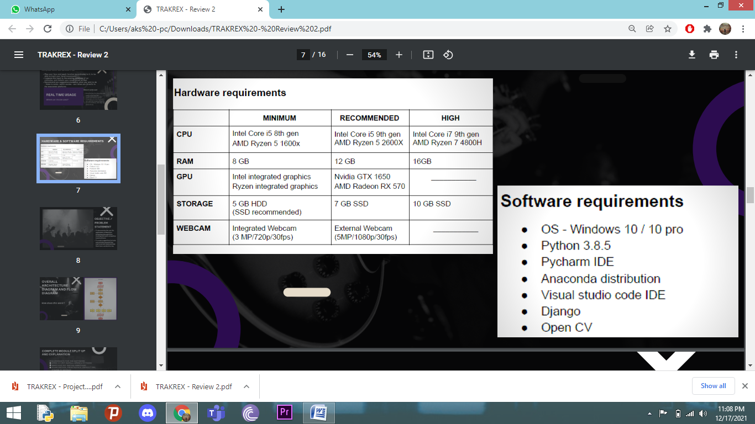

**3.3 Specific Project Requirements**

**3.3.1 Data Requirement: (Same as 3.2)**

**3.3.2 Functions requirement**

1. Opencv(cv2)
2. Deepface
3. Haar-cascade frontal face

**3.4 Summary:**

Requirements stated in 3.3.2 are must. All of them will be provided on our official website. Manually downloading those files may work if you have the correct versions installed.

**CHAPTER-4**

**DESIGN METHODOLOGY AND ITS NOVELTY**

**4.1 Methodology and Goals:**

Our primary goal was to build a software that maps a human face and based on that tracking, detects the emotions and identifies the person's mood, and then integrates the software with entertainment websites and recommends suitable suggestions as per the person's mood.

**4.2 Functional Modules Design and Analysis:**

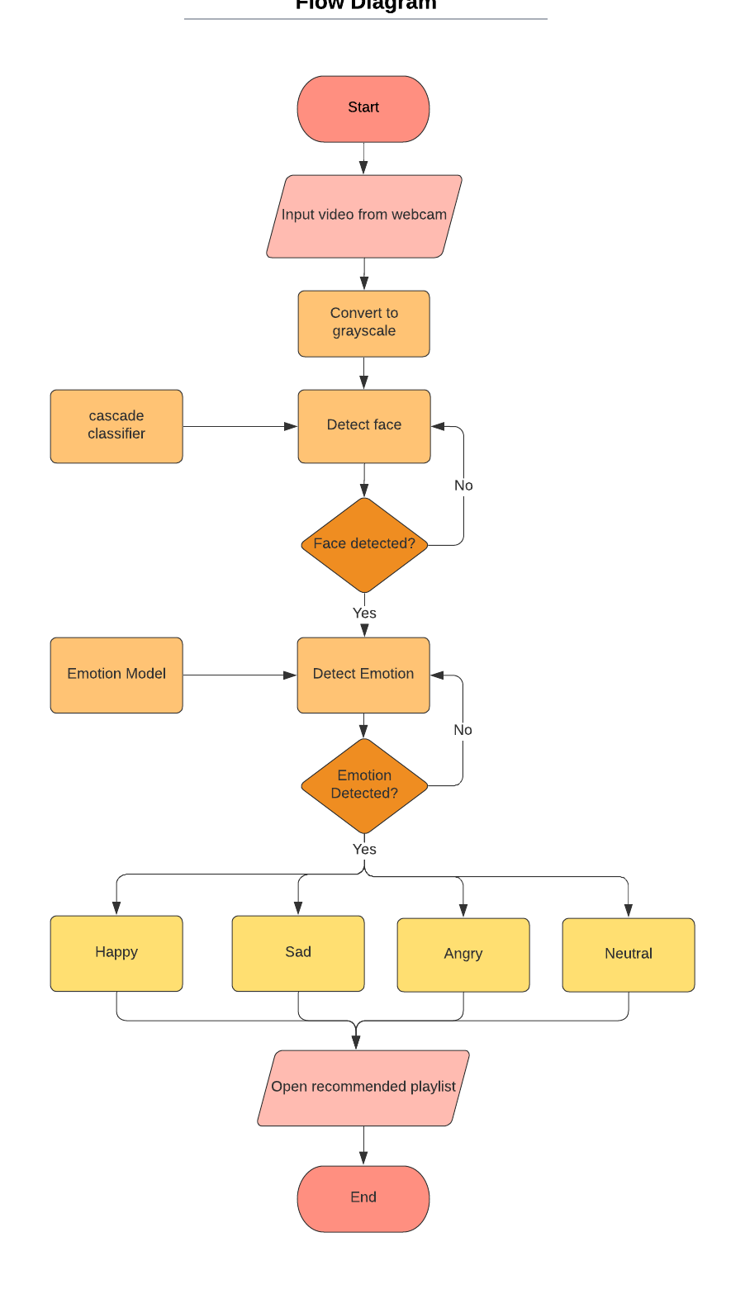

**4.3 Software Architectural Design**

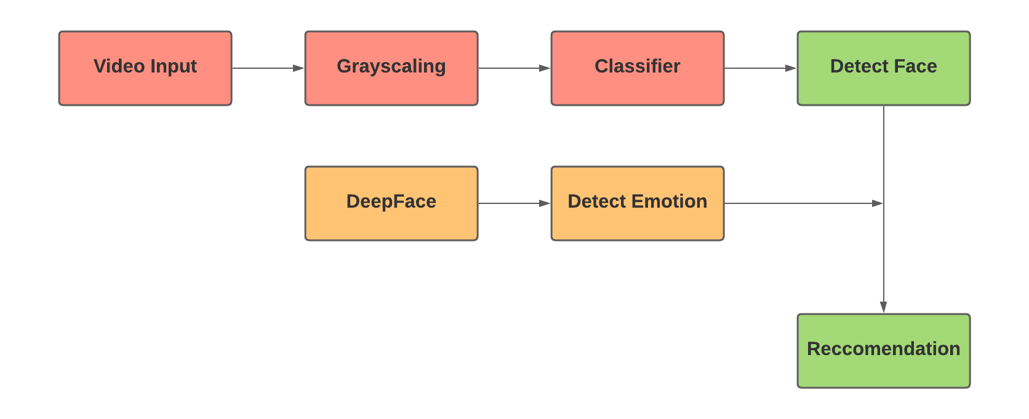

**4.4 User Interface Design**

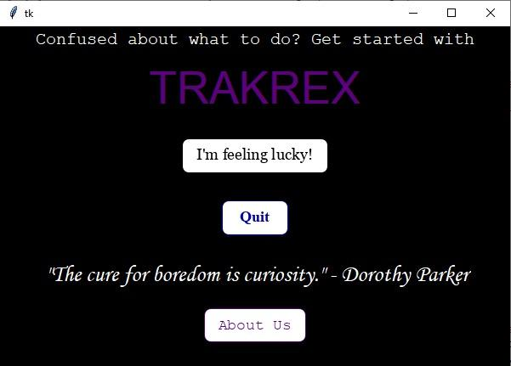

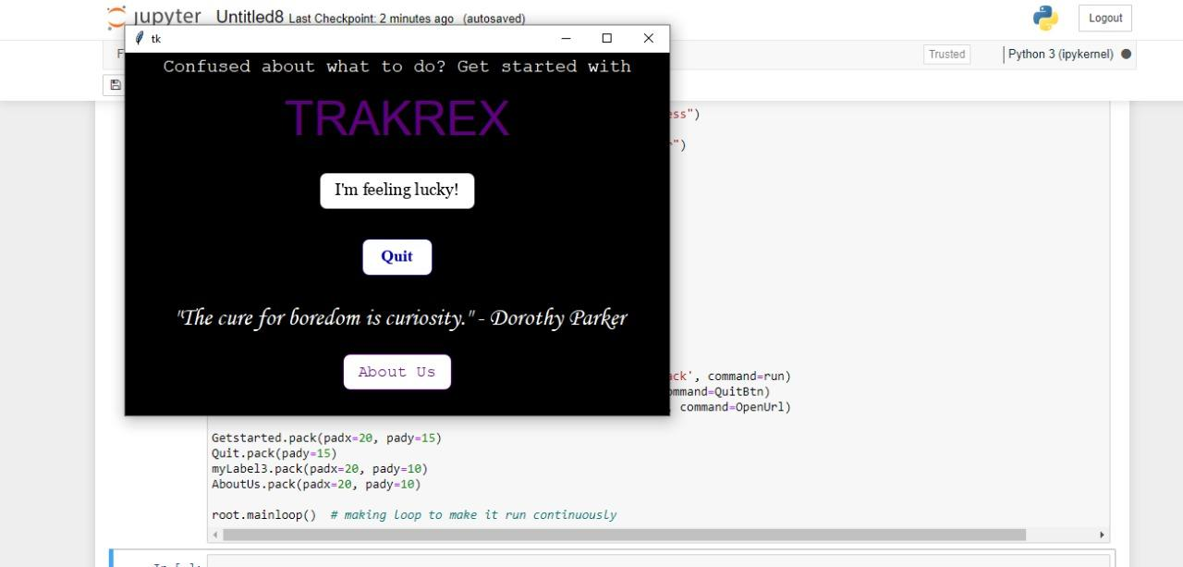

**CHAPTER-5**

**TECHNICAL IMPLEMENTATION AND ANALYSIS**

**5.1 Outline:**

The main body of the code deals entirely with running the facial recognition software to detect the correct mood on the face of the user. Given below is the full program, complete with solutions and output based on running the code.

**5.2 Technical Coding:**

|  |
| --- |
| import cv2 from deepface import DeepFace from tkinter import * from tkinter import ttk import webbrowser  root = Tk() style = ttk.Style() root.geometry('600x400') root.configure(background="black")  myLabel1 = Label(root, text="Confused about what to do? Get started with", font=("Courier", 15), fg='white', bg='black') myLabel1.pack(padx=20, pady=1) myLabel2 = Label(root, text="TRAKREX", font=("Arial", 40), fg='#5c007d', bg='black') myLabel2.pack(padx=20, pady=10) myLabel3 = Label(root, text=' "The cure for boredom is curiosity." - Dorothy Parker', font=("Monotype Corsiva", 20),fg='white', bg='black')  def OpenUrl():  webbrowser.open('https://trakrexx.wixsite.com/home/about-us')  def QuitBtn():  root.destroy()  def run():  # faceCascade = cv2.CascadeClassifier(cv2.data.haarcascades + 'haarcascade_frontalface_default.xml')  faceCascade = cv2.CascadeClassifier('haarcascade_frontalface_default.xml')   cap = cv2.VideoCapture(1)  # Check if the webcam is opened correctly  if not cap.isOpened():  cap = cv2.VideoCapture(0)   if not cap.isOpened():  raise IOError("Cannot open webcam")   while True:  ret, frame = cap.read() ## read one image from a video   result = DeepFace.analyze(frame, actions=['emotion'], enforce_detection=False)  gray = cv2.cvtColor(frame, cv2.COLOR_BGR2GRAY)   # print (faceCascade.empty())  faces = faceCascade.detectMultiScale(gray, 1.1, 4)   # Draw a rectangle around the faces  for (x, y, w, h) in faces:  cv2.rectangle(frame, (x, y), (x + w, y + h), (0, 255, 0), 2)   font = cv2.FONT_HERSHEY_SIMPLEX   # Use putText() method for  # inserting text on video  cv2.putText(frame,  result['dominant_emotion'],  (50, 50),  font, 3,  (0, 0, 255),  2,  cv2.LINE_4)  cv2.imshow('Original video', frame)   dominant_emotion = result['dominant_emotion']   if cv2.waitKey(2) & 0xFF == ord('q'):  if dominant_emotion == 'neutral':  webbrowser.open("https://trakrexx.wixsite.com/neutrality")  if dominant_emotion == 'happy':  webbrowser.open("https://trakrexx.wixsite.com/happiness")  if dominant_emotion == 'sad':  webbrowser.open("https://trakrexx.wixsite.com/sadness")  if dominant_emotion == 'angry':  webbrowser.open("https://trakrexx.wixsite.com/anger")  break   cap.release()  cv2.destroyAllWindows()  Getstarted = Button(root, text="I'm feeling lucky!", borderwidth=0, height=2, width=18, bg='white', fg='#7F14B1', font='Arial', command=run) Quit = Button(root, text="Quit", borderwidth=0, bg='white', height=2, width=10, fg='#000AFF', font='Arial', command=QuitBtn) AboutUs = Button(root, text="About Us", borderwidth=0, bg='#00FFD1', width=15, height=2, font='Arial', command=OpenUrl)  Getstarted.pack(padx=20, pady=15) Quit.pack(pady=15) myLabel3.pack(padx=20, pady=10) AboutUs.pack(padx=20, pady=10)  root.mainloop() # making loop to make it run continuously |

**5.3 Working Layout**

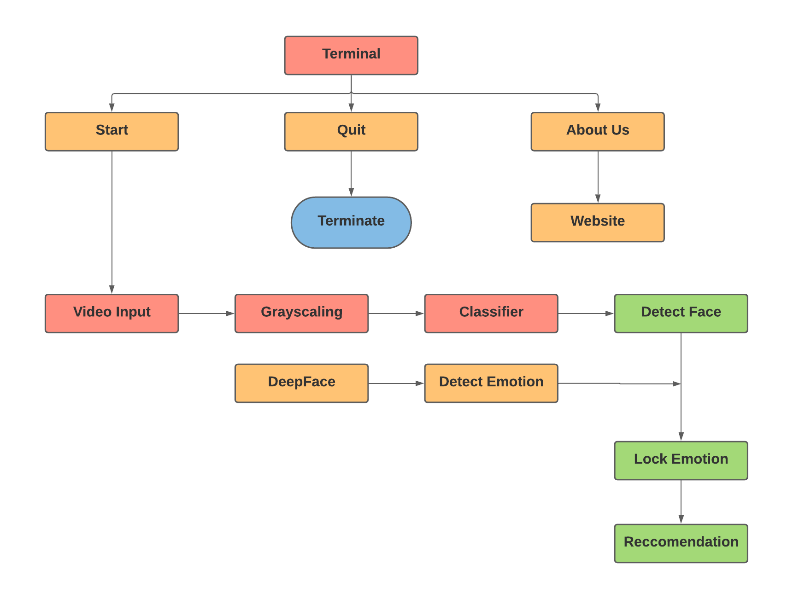

**5.4 Prototype Submission (earlier version of code)**

|  |
| --- |
| import cv2 from deepface import DeepFace import webbrowser  #faceCascade = cv2.CascadeClassifier('haarcascade_frontalface_default.xml') faceCascade = cv2.CascadeClassifier(cv2.data.haarcascades + 'haarcascade_frontalface_default.xml')  cap = cv2.VideoCapture(1)  # Check if the webcam is opened correctly if not cap.isOpened():  cap = cv2.VideoCapture(0)  if not cap.isOpened():  raise IOError("Cannot open webcam")  while True:  ret, frame = cap.read() # read one image from a video   result = DeepFace.analyze(frame, actions=['emotion'], enforce_detection=False)  gray = cv2.cvtColor(frame, cv2.COLOR_BGR2GRAY)   # print (faceCascade.empty())  faces = faceCascade.detectMultiScale(gray, 1.1, 4)  # DetectMultiscale detects the objects   # Draw a rectangle around the faces  for (x, y, w, h) in faces:  cv2.rectangle(frame, (x, y), (x + w, y + h), (0, 255, 0), 2)   font = cv2.FONT_HERSHEY_SIMPLEX   # Use putText() method for  # inserting text on video  cv2.putText(frame,  result['dominant_emotion'],  (50, 50),  font, 3,  (0, 0, 255),  2,  cv2.LINE_4)  cv2.imshow('Trakrex', frame)   dominant_emotion = result['dominant_emotion']   if cv2.waitKey(2) & 0xFF == ord('q'):  break  cap.release() cv2.destroyAllWindows() |

**5.5 Test and Validation**

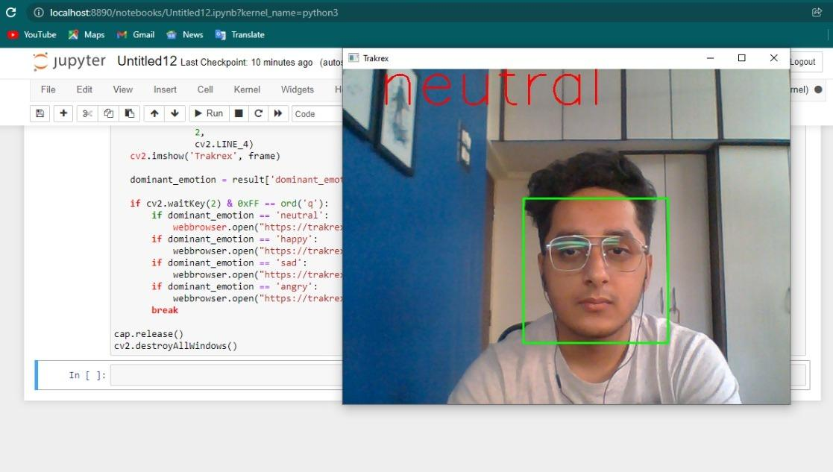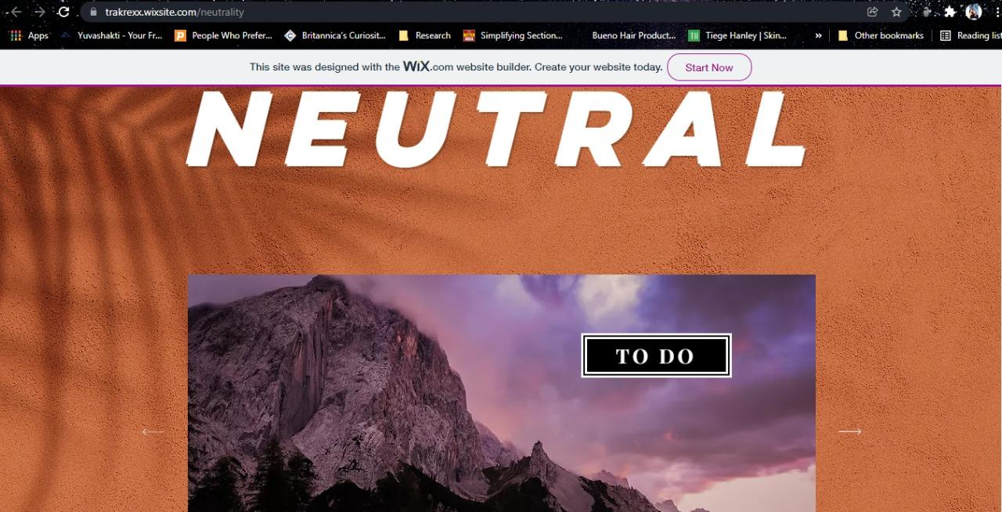

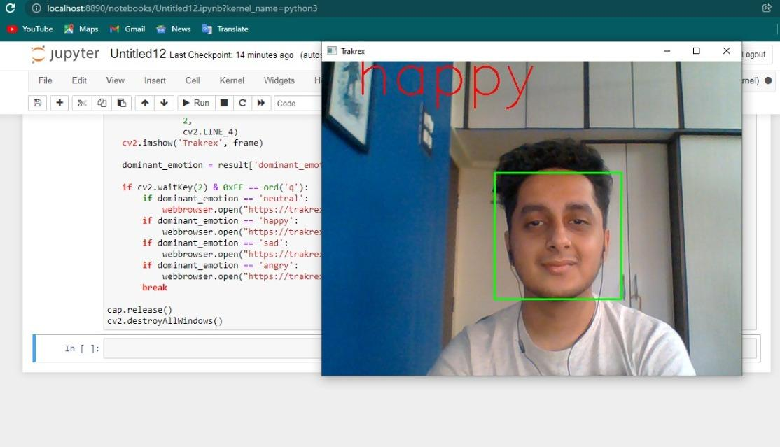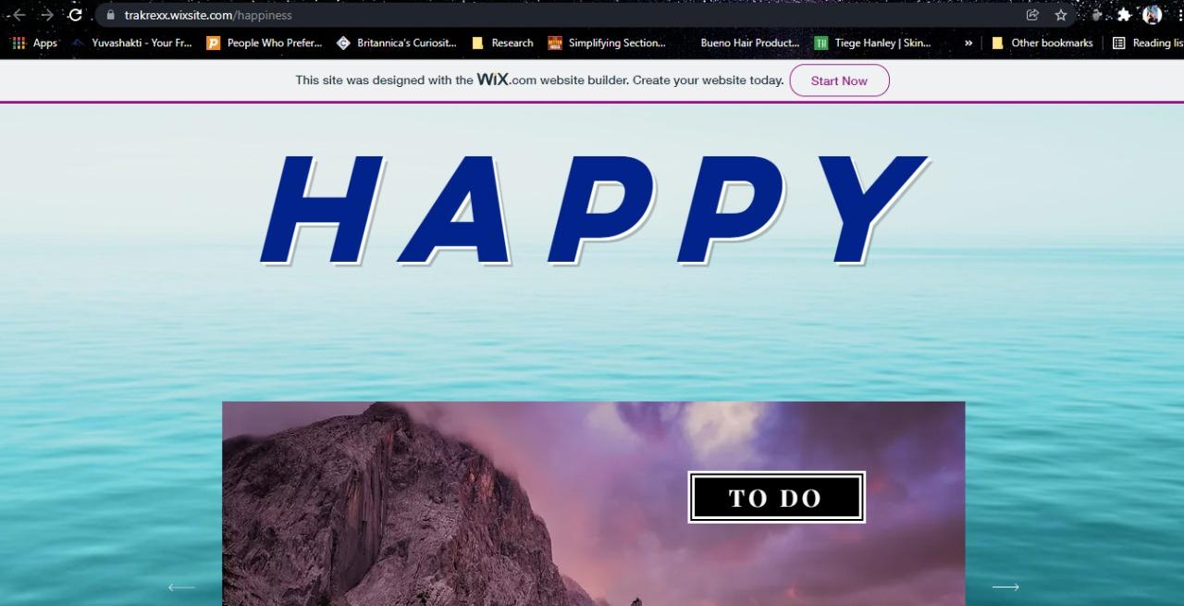

**5.6 Performance Analysis**

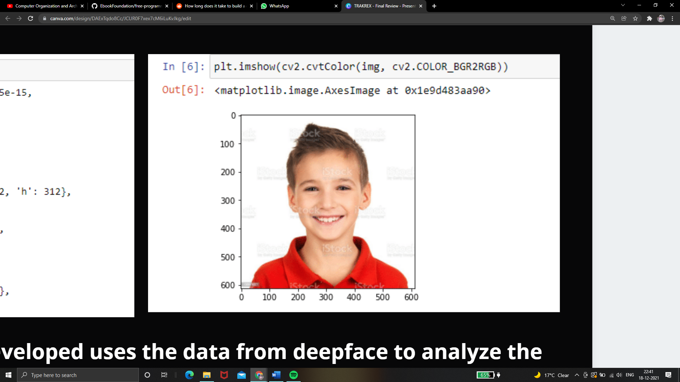

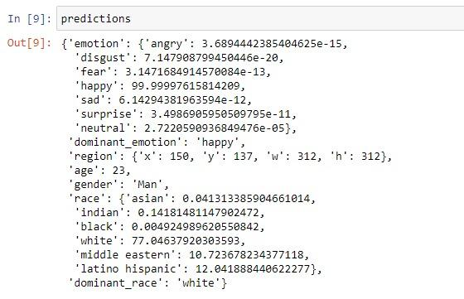

The program we have developed uses the data from deepface to analyze the faces and detect the emotions. As you can see in the above testing, the dominant emotion is 'happy' with an accuracy of 99.99 points.

**CHAPTER - 6**

**PROJECT OUTCOME AND APPLICABILITY**

**6.1 Outline**

The project was designed keeping in mind the simple need of finding a solution to the problem of indecision most people face on a daily basis. It was developed to help recommend users different activities and movies and songs, and help them save the time that’d be spent on such tasks and focus it on more productive tasks.

**6.2 Key Implementations Outlines of the System:**

The terminal section of the system will serve as a simple yet clean user interface to welcome the users to the program, and provide them with the necessary tools in one window.

The emotions detection program will find out the user’s mood and guide them to the related appropriate webpage designed to provide them with a list of movies, songs, and activities that’ll help them spend their time effectively.

**6.3 Significant Project Outcomes:**

The program achieved the original objective of designing and implementing a system that would recommend entertainment and productivity options for users, and also help them save time in coming up with such solutions by doing it for them. Operating with the input of the user’s facial expressions would simplify the process, and take it one step further towards being efficient.

**6.4 Project Applicability on Real-World Applications:**

The project can be used for personal use in homes as an accessibility device, when the user simply wants to use the recommendation systems. It can also be used in offices and workplaces, in order to ensure that employees can use their daybreaks efficiently.

**6.5 Inference**

Working on this project has provided us with the knowledge that it is important to ensure that projects of such nature are made accessible to the public, so that a maximum number of people can avail their benefits. The effort and time spent on designing such projects, is ultimately contributing towards making human lives easier and hence, more and more such projects should be actively encouraged and funded.

**CHAPTER - 7**

**CONCLUSIONS AND RECOMMENDATIONS**

**7.1 Outline**

In conclusion, we would like to thank our appointed faculty and project guides for giving us enough time to help explore this wonderfully informative topic and create something that, ideally, would be super helpful and productive to anyone who ever needs it.

**7.2 Limitation/Constraints of the System**

Due to the unavailability of proper funding, some of the features of the program cannot be worked on and this makes it somewhat less accessible to the general public. This makes it a program mainly for testing by programmers and the more technically inclined. In order to also make it more accessible for other users, some features have to be made simpler and therefore less practical.

**7.3 Future Enhancements**

In the near future, if our little idea gains enough steam, we would like to expand our recommendations catalog beyond just movies, music and hobbies to pass your time with. In fact, we would like to add things like TV shows, books, and other similar palatable art forms through our primary website.

**7.4 Inference**

Working on this project provided us with invaluable technical and teamwork experience. We also realized that the effort and time spent on designing such projects is ultimately contributing towards making human lives easier. Hence, such projects need to be encouraged and funded.

**REFERENCES**

1. M. R. Mizna, M. Bachani and S. Memon, "Blue eyes technology," Eighth International Conference on Digital Information Management (ICDIM 2013), 2013, pp. 294-298, doi: 10.1109/ICDIM.2013.6693995.
2. A. A. Varghese, J. P. Cherian and J. J. Kizhakkethottam, "Overview on emotion recognition system," 2015 International Conference on Soft-Computing and Networks Security (ICSNS), 2015, pp. 1-5, doi: 10.1109/ICSNS.2015.7292443.
3. Y. Taigman, M. Yang, M. Ranzato and L. Wolf, "DeepFace: Closing the Gap to Human-Level Performance in Face Verification," 2014 IEEE Conference on Computer Vision and Pattern Recognition, 2014, pp. 1701-1708, doi: 10.1109/CVPR.2014.220.